**Master SpringBoot**

**13-SpringBoot Actuator Micrometer:**

**Step-00: Introduction to Actuator**

**Step-01: New GIT branch (using IDE)**

* **Git Branch name: 14-SpringBoot-Actuator-Micrometer**
* **Create new local branch**

**Step-02: Add Micrometer dependency for Metrics**

**<dependency>**

**<groupId>io.micrometer</groupId>**

**<artifactId>micrometer-core</artifactId>**

**<version>1.8.1</version>**

**</dependency>**

* **Simple (In-Memory backend – Fall back option) – by default enabled**
  + **To disable: management.metrics.simple.enabled=false**
  + [**http://localhost:8080/actuator/metrics/http.server.requests**](http://localhost:8080/actuator/metrics/http.server.requests)

**Step-03: Integrate with JMX and view metrics in JConsole using JMX (Export Metrics)**

* **Add the JMX dependency**

**<dependency>**

**<groupId>io.micrometer</groupId>**

**<artifactId>micrometer-registry-jmx</artifactId>**

**<version>1.8.1</version>**

**</dependency>**

* **Add JMX property**
  + **management.metrics.export.jmx.enabled: true**

**Create a new Branch:**

**git status:**



**git checkout –b 14-SpringBoot-Actuator-Micrometer**



**Add client dependency for micrometer:**

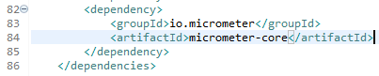

**Check the URL:**

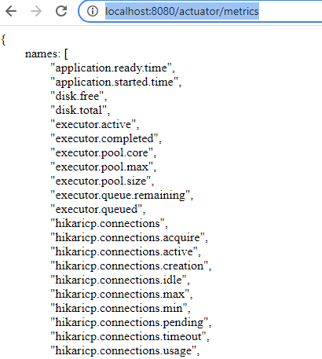

**Localhost:8080/actuator/metrics/http.server.requests**

